Multi-Factor Authentication Systems:
A Comparative Analysis of Four Industry Implementations

Team 00
Thao H. B. Bui – buithao1@cityuniversity.edu
Duy K. Bui - buikhanhduy@cityuniversity.edu
School of Technology and Computing, City University of Seattle
CS504_01_IN: Software Engineering
Professor Marcelo Guerra Hahn
September 8, 2026

Abstract

Multi-Factor Authentication (MFA) is a vital security measure for protecting account users against passwords theft or phishing. This team project analyzes and compares between four MFA implementations based on Authenticator Assurance Level (AALs) as defined in NIST Special Publication 800-63B. The team selects four authentication mechanisms ranging from simple to complex including: Memorized secrets combined with OTP/TOTP; Multi-Factor Cryptographic Software; Multi-Factor Cryptographic Device; and Federation and Assertions. By comparing these four mechanisms based on AAL assurance, the team will create a report regarding to the tradeoff between security and usability when choosing an appropriate MFA method for deployment.

Keywords: Multi-Factor Authentication, Authentication Assurance Level, Memorized Secrets, Cryptographic Authentication

- INTRODUCTION

Digital authentication is a core layer protection for most online services today. However, the most common method is a combination of username and password, which is the weakest link. It is especially vulnerable when users reuse the same password across multiple platforms. MFA was introduced to address this issue by combining two or more independent evidence such as what a user knows or possesses. In accordance with NIST Special Publication 800-63B, the AAL framework enables organizations to select an appropriate security level to their risk profile.

Based on this AAL framework, our team report presents four representative MFA methods ordered by increasing complexity. Four examples include memorized secrets combined with one-time codes (AAL2), cryptographic software such as WebAuthn/Windows Hello (AAL2), hardware-based cryptographic devices like the Titan Security Key (AAL2/AAL3), and federated identity authentication via OpenID Connect/Microsoft Entra ID (AAL1–AAL3). We then compare and choose to use the appropriate authentication method for our project.

- LITERATURE REVIEW

Many academic studies have shown that the fundamental weakness of single factor authentication is not only about technical aspects but also in user behavior. Das et al. (2019) through a systematic review of 623 academic papers on MFA, indicated that although MFA tools are very technologically advanced, user acceptance and actual usage remained highly barriers, require more specific users’ research to design a friendlier tool. This result is compatible with findings of De Cristofaro et al. (2013), who conducted research comparing usability of many different authentication technologies and saw that even though multi-factor authentication enhanced security, it also increased high cost for both providers and users.
The trade off between security and user experience from Amft et al. (2023), which focuses on account recovery when user loses access to second authentication factor like a mobile device or a hardware security key. This research also presses on recovery process undermines the entire MFA security process, bringing a critical challenge that systems like hardware security key or OTP must face.

At the industrial implementation level, Tran-Truong et al. (2025) conducted a systematic review on 70 academic papers and 13 commercial authentication tools, benchmarking with NIST SP 800-63 standards, especially AAL framework used in this team report. A notable finding is there is the significant gap between academic theory and implementation practices. Although more advanced authentication methods have widely been proposed in research, there is up to 33% of industry tools still rely primarily on OTP, a method standing at a lower level of assurance under the AAL classification. This finding reinforces that the selection of the four methods in sequence from AAL1 to AAL3 reflects not only the technical side but also the actual gap between widely used methods and that higher security but lower adoption use.

- METHODOLOGY

Our team project aligns to the first category mentioned in the Introduction as memorized secrets combined with one time code. It is in NIST AAL framework that places up to AAL2 compared to the categories discussed in the Introduction. Our team project applies multifactor authentication using Flask, Flask-WTF, Flask-SQLAlchemy, SQLite, bcrypt, Flask-Mail, and Flask signed session cookie. Below are the six applied mechanisms.

  - Cross-Site Scripting (XSS)

XSS appears when web inserted inputs are not trustworthy and run as JavaScript in another user browser. Our application displays login and registers through Jinja template in app/templates/. Jinja will auto escape template variables. Therefore, user input only appears as text instead of executable HTML or JavaScript. Usernames and error messages should never be displayed using |safe filter in Jinja.

  - Cross-Site Request Forgery (CSRF)

CSFR tricks user browser with a unintended state changing request while the authentication cookie is still valid. LoginForm and RegisterForm inherit from FlaskForm in app/main/forms.py. Flask-WTF will automatically protect CSFR for these forms. Template calls {{ form.hidden_tag() }} to embed the CSRF token. The form.validate_on_submit() method checks and validates the token before processing login or register.

  - SQL Injection

SQL injection appears when untrusted input combined with SQL statement in a way that changes the meaning of the query. Our team application uses Flask-SQLAlchemy in app/orm_query.py. Retrieving user via User.query.filter_by(username=username) treats username as a query parameter rather than the raw SQL code. Creating a new user using User and db.session.commit() help us avoid concatenating SQL strings from user input.

  - Router Decorators & Blueprint Architecture

Router Decorators connect one URL and HTTP method with a view function. Another different decorator can apply a general rule such as requiring a valid login session before the view executes. Blueprint main is created in app/main/__init__.py and registered within the app factory. Routes utilize decorator like @main.route(‘/login’, …). Protected routes additionally use @login_required, which check the valid username in the session or not. If not, decorator will redirect the user to /login.

  - Session Management

Session management controls how an application establishes, stores, authenticates, and terminates user login state. config.py defines SECRET_KEY used by Flask to sign session cookie. After the username, password, and PIN have been authenticated successfully, the login view should store session[‘username’] = user.username. The @login_required will then request the cookie session before letting protected route access. Logout will clear session[‘username’] and redirect user to login page. In a production environment, the SECRET_KEY should be retrieved from a protected environment variable instead of hardcoded, and cookies should have HttpOnly, Secure, SameSite.

  - Secure Email Delivery (Flask-Mail/SMTP)

Second factor by email OTP appears when the system needs another authentication factor besides password. It is sent via a channel accessible only to the legitimate user. Our application uses Flask-Mail to send a six-digit PIN via email after successful password authentication. The PIN is randomly generated using the ‘secrets’ library and remains valid for only a short period of time before expiration. SMTP connections always utilize TLS on port 587 and email credentials are stored in environment variables rather than being hardcoded.

Besides the PIN, our team also applied email verification during registration with itsdangerous, specifically the URLSafeTimedSerializer class. This serializer generates a signed and time limited token embedded in a verification URL. The URL is http://localhost:5000/verify_email/<token> and is sent to the user's email. Because the token is signed cryptographic, any attempt to change it invalidates the token immediately. It helps to prevent forged verification links. This token also has a built-in expiration set to 60 minutes in our implementation. Therefore, a link that is never clicked cannot be used forever. When the user visits the link, the server verifies that token's signature and expiration before flipping the account's is_email_verified to True.

- ARCHITECTURE

Our system architecture has a three-layer architecture including presentation layer, application logic layer, and data layers. The presentation layer includes HTML pages that renders through Jinja2 templates and are responsible for users' interaction. The application logic layer is handled by Flask that helps process incoming users' requests, applies authentication rules, and coordinates between other layers. Lastly is the data layer. This layer run through SQLAlchemy which helps to map Python objects to underlying SQLite database rather than requiring raw SQL statements. The point of this separation means a change to the visual layout does not require touching authentication logic. Also, it is a change to how data is queried does not require touching the routes that users interact with.

Diagram 1 illustrates our overall application architecture. The user interacts with the frontend, which communicates with Flask backend. The backend then handles authentication logic, session management, and database access to support secure user operations.

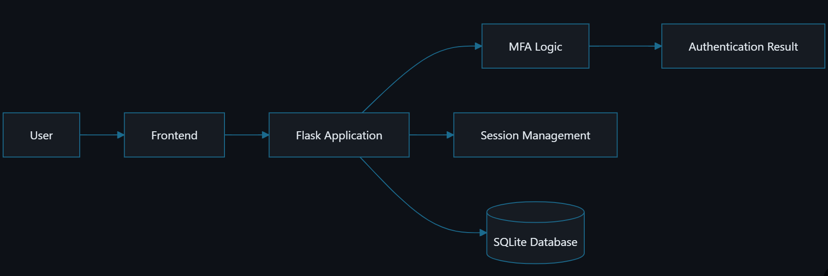
Diagram 1: Overall System Architecture
Within the logic layer, the team implemented Flask's application factory pattern with Blueprints. Both the practices are recommended in Grinberg's Flask Web Development and the official Flask documentation. Instead of creating the Flask app instance directly at the top of a single file, the team built and configured a create_app() function at runtime. This is an improvement over the simpler style shown in class, where a single global app object is created immediately and every route is attached to it directly with @app.route.

That approach works for a small script but will create two more practical issues when the application grows. Firstly, it is difficult to create differently configured instances of the app. For instance, one for testing and one for production. Therefore, it is easy to face circular import errors when the models, forms, and routes start depending on each other.

The application factory solves this by delaying app creation until create_app() is called. Then Blueprints solve the related issue for route registration. Because routes can no longer be attached with the bare @app.route decorator before the app exists anymore. Flask's Blueprint mechanism now allows routes to be registered to a named blueprint first. And only then can it bound to the real application afterward inside the factory function. This is also what allows our application main blueprint to group views.py, form.py, and errors.py together as a complete unit instead of scattering related functionality across the codebase.

Diagram 2 illustrates our full authentication sequence between frontend, backend, and database. The flow begins when a user enters credentials in the browser. It then sends them to the Flask application via POST /login. The Flask app queries SQLite for the matching user's record and then verifies the password. Only after the password is confirmed does the system start to generate a one time PIN and send it through email. This order is very important. Since it makes sure the second factor is never issued before the first factor. Once the user retrieves the PIN and submits it back to the Flask app, the server sets a signed session cookie. All the subsequent requests like GET are authenticated using that cookie instead of requiring the user to login again.

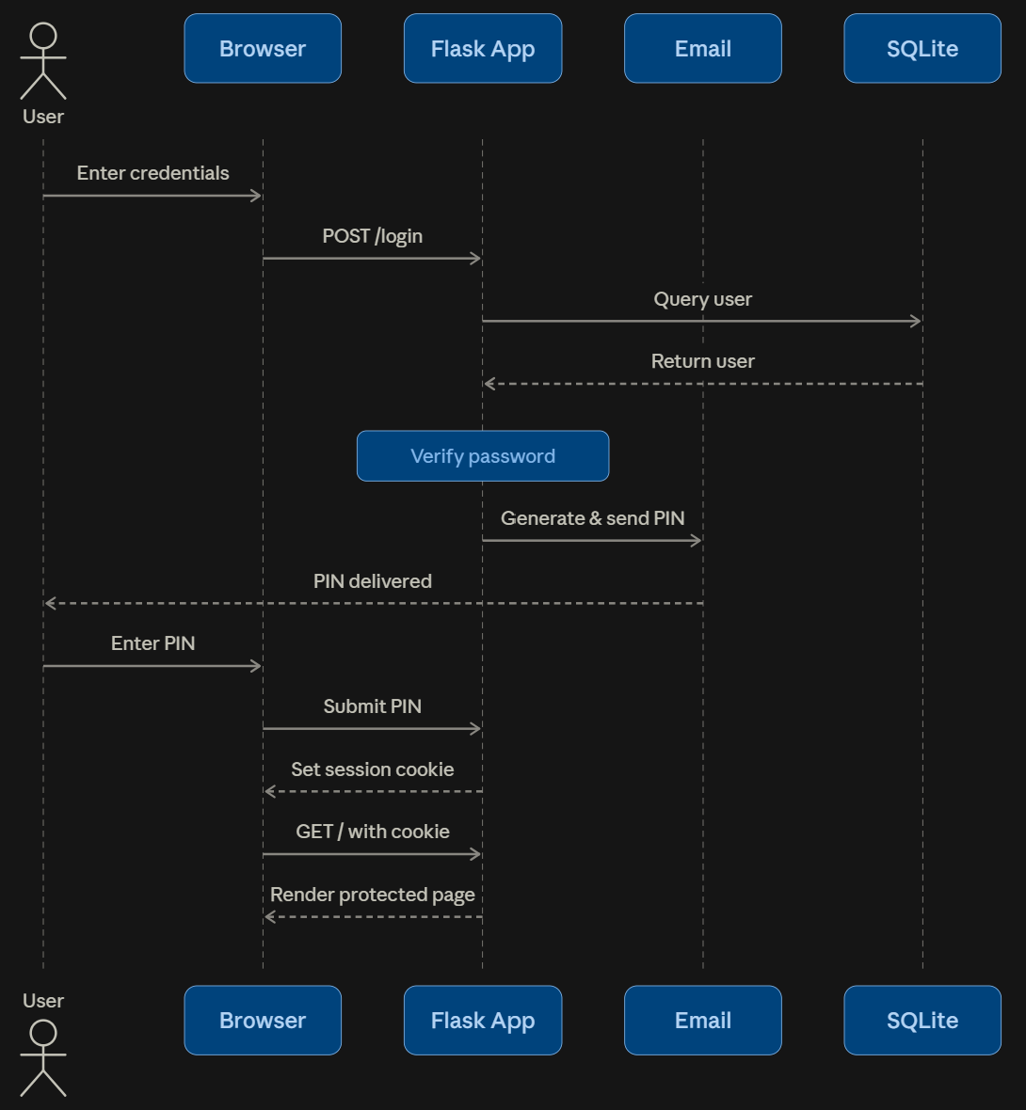
Diagram 2: Authentication Sequence with Email-Based Second Factor
Diagram 3 illustrates our registration and email verification flow. The flow begins when a user submit their username, password, and email through the registration form. Then the Flask app creates a new user record. The account is still marked as unverified at this point. Then it generates a signed and time limited token using itsdangerous and sends a verification link to the user email through FlaskMail. The account verification status will only change to true when the user clicks that link. This order is very crucial. Because it makes sure that no account can log in without first proving ownership of the registered email. After verified, the user can proceed to the login flow where the same email is reused to deliver the one time PIN.

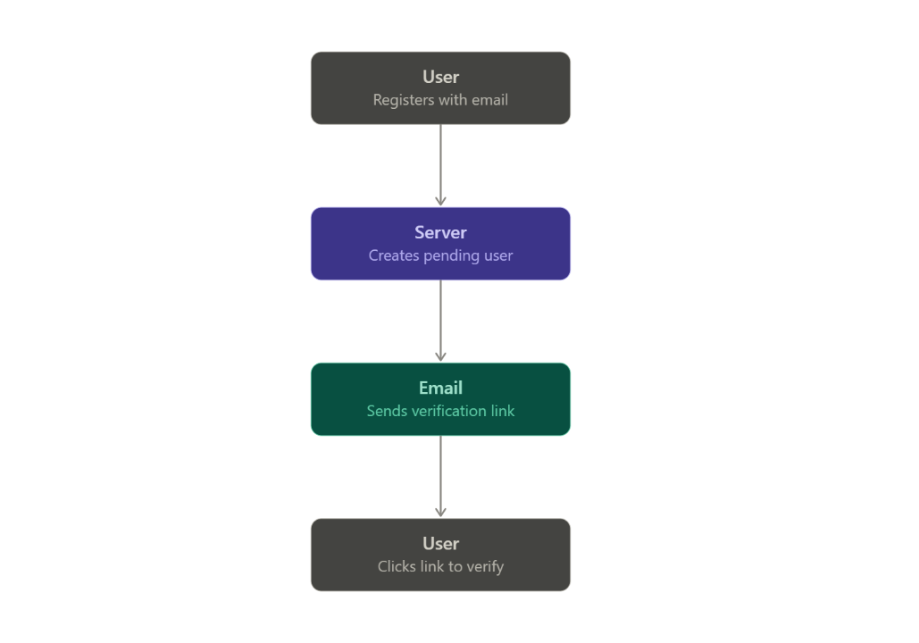
Diagram 3: Registration & Email Verification Flow

Diagram 4 illustrates our complete application modular structure.

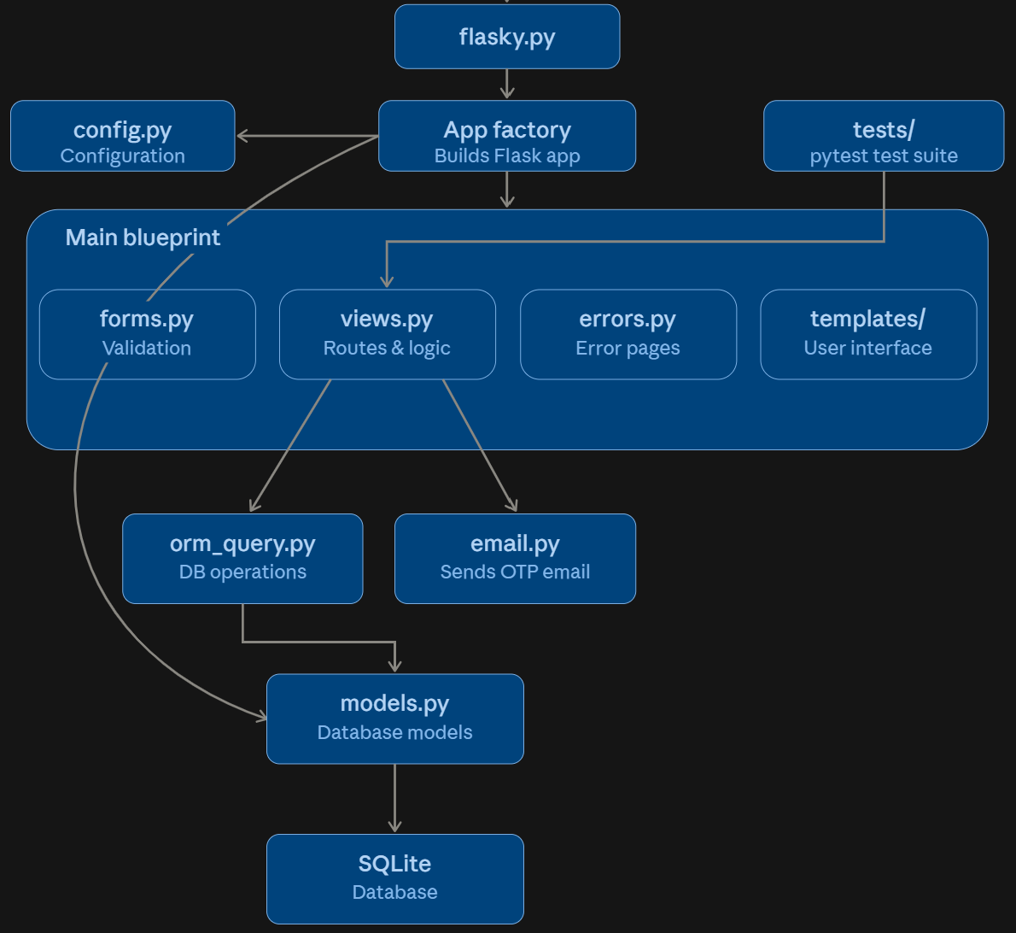
Diagram 4: Modular Structure of Whole Application
The three diagrams show our application at three different detail levels. Diagram 1 shows a high level system view. Diagram 2 shows how a single authentication request actually goes through the system over time. Diagram 3 shows how the codebase is organized to support the workflow. The layer view of these is what allowed our team to reason for where each security control is within the application in Methodology.

- RESULTS

  - Core Authentication Flow

The results demonstrate that the system has fully implemented the multifactor authentication workflow including registration, login, and session management. During registration, users provide username, password, and email. The account is then created in a pending state (‘is_email_verified=False’) and cannot be logged into until verified via an email link. The link is generated by using the ‘URLSafeTimedSerialized’ from the ‘itsdangerous’ library and automatically expires after 60 minutes.

During the login process, the system first checks the username and password. Only if both are valid does it generate a random six digit PIN using the ‘secrets’ library and send it via email using Flask-Mail. The user then enters the code to complete the authentication and a session is established via Flask-Login using ‘login_user()’ to maintain the logged-in state for the subsequent request.

  - Security Controls

Our system employs specific security mechanisms at each layer. CSRF protection is handled by Flask-WTF where each form inherits from ‘FlaskForm’ and embeds a token via ‘{{ form.hidden_tag() }}’. The input is then validated using ‘form.validate_on_submit()’ before the logic is processed. SQL injection is prevented by the SQLAlchemy ORM. Specifically, ‘User.query.filter_by(username=username)’ treats the input as a parameter instead of an executable code. Both password and PIN are hashed by bcrypt before stored in the database. XSS is mitigated by Jinja2’s default auto escaping mechanism when rendering the template’s variables.

Security Layer | Applicable Mechanism
CSRF | Flask-WTF: FlaskForm, {{ form.hidden_tag() }}, form.validate_on_submit()
SQL Injection | SQLAlchemy ORM: User.query.filter_by(username=username)
Password & PIN Hashing | bcrypt for both before storing in database
XSS | Jinja2 auto escape by default when rendering variables
Table 1: Security Mechanism & Implementation
  - AAL Evaluation

When we evaluated the system against the AAL framework of NIST SP 800-63B-4, using an email-based OTP as a second factor. Using an email to deliver OTP as a second factor instead of user’s selected PIN give the system a “something you have” element alongside with the password.

However, email OTPs do not yet offer a strong level of robust security as TOTP or hardware keys. Since the email account itself is typically protected only by a password. This is a limitation explicitly stated in this report instead of being overlooked. It accurately reflects the gap between theory and our practical implementation.

- CONCLUSION

The team has successfully developed a multifactor authentication system through Flask application. It covers the entire workflow from registration, email verification, and sequential authentication to session management via Flask-Login. The second factor using email-based OTP rather than letting the users choose their own PIN brings the system closer to a true possession factor. However, under the NIST AAL framework, email OTPs do not offer the same level of assurance as TOTP. Because the email account itself is protected merely by another password.

The team drew several lessons as we practiced. Firstly, design documentation and actual code can easily diverge without a frequent cross checking. Secondly, security is often overlooked under deadline pressure which leads to vulnerabilities like missing CSRF protection or plaintext logging. Lastly, choosing email-based OTP over TOTP represented a deliberate trade off between feasibility and an ideal level of assurance.

Our team report also has certain limitations. The security assessment relied mainly on manual code review rather than penetration testing. System usability testing with actual users was not conducted. And lastly, the system was developed on the scale of a course project making it difficult to generalize the results to a larger real world systems.

- REFERENCES

Amft, S., Höltervennhoff, S., Huaman, N., Krause, A., Simko, L., Acar, Y., & Fahl, S. (2023). "We've disabled MFA for you": An evaluation of the security and usability of multi-factor authentication recovery deployments. In Proceedings of the 2023 ACM SIGSAC Conference on Computer and Communications Security (pp. 3138–3152). ACM. https://doi.org/10.48550/arXiv.2306.09708
Das, S., Wang, B., Tingle, Z., & Camp, L. J. (2019). Evaluating user perception of multi-factor authentication: A systematic review. arXiv. https://doi.org/10.48550/arXiv.1908.05901
De Cristofaro, E., Du, H., Freudiger, J., & Norcie, G. (2013). A comparative usability study of two-factor authentication. arXiv. https://doi.org/10.48550/arXiv.1309.5344
D2L. (2026). About LTI 1.3 launch and authentication. Brightspace Community. https://community.d2l.com/brightspace/kb/articles/23730-about-lti-1-3-launch-and-authentication
Google. (n.d.). Titan security key. Google Cloud. Retrieved July 24, 2026, from https://cloud.google.com/security/products/titan-security-key
Grinberg, M. (2018). Flask Web Development. O’Reilly Media. https://ia903202.us.archive.org/31/items/python_ebooks_2020/Flask_Web_Development_%28en%29.pdf
Microsoft. (2023). Trusted Platform Module technology overview. Microsoft Learn. https://learn.microsoft.com/en-us/windows/security/hardware-security/tpm/trusted-platform-module-overview
Microsoft. (2026a). Introduction to Microsoft Entra tenants. Microsoft Learn. https://learn.microsoft.com/en-us/microsoft-365/education/guide/1-reference/introduction-microsoft-entra-id
Microsoft. (2026b). Set up Microsoft Entra ID. Microsoft Learn. https://learn.microsoft.com/en-us/intune/solutions/education/tutorial-school-deployment/setup-entra-id
Microsoft. (2026c). Web Authentication APIs. Microsoft Learn. https://learn.microsoft.com/en-us/windows/security/identity-protection/hello-for-business/webauthn-apis
Mozilla Developer Network. (n.d.). Web Authentication API. MDN Web Docs. Retrieved July 24, 2026, from https://developer.mozilla.org/en-US/docs/Web/API/Web_Authentication_API
Temoshok, D., Choong, Y., Regenscheid, A., Galluzzo, R., Fenton, J., Richer, J., & Lefkovitz, N. (2025). Digital identity guidelines: Authentication and authenticator management (NIST Special Publication 800-63B-4). National Institute of Standards and Technology. https://doi.org/10.6028/NIST.SP.800-63B-4
Tran-Truong, P. T., Pham, M. Q., Son, H. X., Nguyen, D. L., Nguyen, M. B., Tran, K. L., Van, L. C. P., Le, K. T., Vo, K. H., Kim Ngan, N. T., & Nguyen, T. M. (2025). A systematic review of multi-factor authentication in digital payment systems: NIST standards alignment and industry implementation analysis. Journal of Systems Architecture, 162, 103402. https://doi.org/10.1016/j.sysarc.2025.103402

- WORKLOAD ASSIGNMENT

Thao: Paper writing and structuring, diagram design, PowerPoint presentation preparation.
Duy: Application development and testing.

